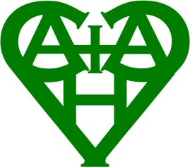

CHURCH AND CHEYWYND ASTON VILLAGE HALL

SAFEGUARDING POLICY

As a committee we all recognise the importance of safeguarding all users of the hall. Therefore, we require that all groups using the hall have an appropriate safeguarding policy in place and ask that the group organisers confirm this.

In the event of an incident, the group should first try to resolve the issue. If this fails, they can refer to a member of the committee who will try to help with a solution. Should the committee member be unable to give immediate assistance, he may refer to the Telford and Wrekin Family Connect Group on 01952 385385 Option 2 for an Adult or Option 1 for a child.

